HOW TO HOST THE CODEJIKA.COM “1-HOUR WEBSITE” EVENT

Instructional Document

What is the 1 Hour Website?
- Fun event, participants learn to code a simple landing page.
- No software, no internet, no experienced trainers are required.
- Duration: 1 hour
- Managed by a student, school teacher or Club Mentor.

What you need:
- Computers or laptops.
- “1 Hour Website” Curriculum.
- Students who you will train(Ask the principal if you can start with a group of 8th or 9th graders).
- Register(A piece of paper and pen for the students to write down their name, surname and grade). Take a picture of the register and send us the photo of the register later.

Venue or School PC Lab
Some tips around the venue:
- Remind School of the event multiple times.
- Make sure to get contact numbers of an additional person at the school or (other PC Lab) and ensure you remind them both a few days before.
- Check the PCs or each laptop in the lab, just make sure you have the correct logins, the desktops are set up well, PCs are functional and the curricular material is copied to and accessible on the desktop of each PC.
- Print the 1 hour website curriculum or copy it on a usb drive and copy it to the desktop of each PC in the school lab.
- Make sure you have enough copies and don’t wait till the day before. There are often unforeseeable problems with printers or files.

Promote your “1 Hour Website” Event(Optional)
You may use some or all of these ideas:
- Print A3 Posters – Fill in the details with a black marker and post 10-15 in key areas around the school (or community.) Click here to download the poster.

Plan your technology needs
Check if your computer has:
- Notepad ( Click: “Start” & type “Notepad” it should already be on any PC.)
- Adobe Reader ( Every PC should have a program that can view PDFs.)
- Internet Browser (You don’t need internet, but you need a browser. Any browser will work; Internet Explorer, Firefox, Chrome, Opera or Safari. )
- See if the computer/laptop log in details work.
- Check to see if each keyboard and mouse works properly.
- Download the “1 Hour Website” copy to each PC that you will be using.Click here to download the “1 hour website”.
- Paste the “1 hour website” Folder onto the desktop of each PC or Laptop or you can print out copies.
- Go through the lessons yourself first.
- Run a virus scan on your PCS (If you need an Antivirus you can use FREE Avast or any other: www.avast.com, this is optional )

Optional
- Start your “1 Hour Website” with an inspiring speaker or video
- Have a role-model speaker or personality give a short talk about coding or learning new skills.
- Play a Video: Or play one of these fun videos to inspire the team before they start:
  - 2017 Coder of the Year Awards – 1 Min: https://www.youtube.com/watch?v=LCvuh-chXnA
  - Code for Change – Meet the Team - 3 Mins: https://www.youtube.com/watch?v=da82NIbzsHo
  - Why I learned to Code 13 Reasons – Young Girl: 5 Mins: https://www.youtube.com/watch?v=YqcVA32OVz4
  - Do an Ice-breaker Game: Get the student excited, awake and interacting with a partner.
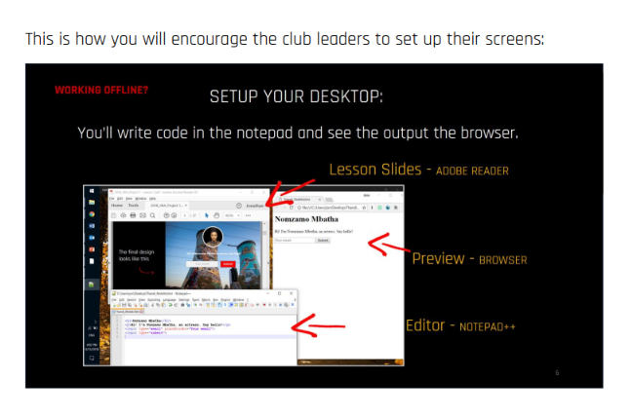

Celebrate
- That’s amazing! You’ve come to the end. Make sure to celebrate with your whole team and all the great students.What a fantastic start to a new career, new ideas and a new future for many.
- Don’t forget to take photos of the learners and some of their websites.
- Please send us an email with all photos and the register of your intro session to hello@codejika.com . Don’t forget to please tell us the name of the school, city and how many students you trained in the same email.

What comes after the “1 Hour Website” Event?
- Speak to the principal about hosting a 5 minute presentation during the next assembly where you will tell the entire school about the CodeJIKA program.
- Ask the principal if you can start training with 2 groups.

If you need support, please contact
General Inquiries- hello@codejika.com

